

INFRASTRUCTURE APPLICATION REQUIREMENTS – Werk.nl_database_copy

Version: 0.2

Date: *08-12-2023*

Document purpose

This requirements document (REQ) is used to:

* Gain a common understanding of the application requirements
* Document the requirements relevant for the DXC Infrastructure Application design (IA HLD)

The document outlines:

* External entities
* Functional and non-functional requirements

Relation to other documents

The following documents may be relevant as context to this REQ:

* The Software Architecture Document (SAD)
* The Project Start Architecture (PSA) document
* Infrastructure Application design produced by DXC for related applications (interfaces)

Structure of the document

High level flow: first the application overview and architecture are described followed by the functional and non-functional requirements that ‘drive’ the solution as it will be described in the DXC HLD.

Content of the document

UWV has prepared this document in good faith and is based on the information gathered during the requirement determination phase with all parties involved; application vendors, UWV architects, developers and UWV functional management.

Table of Contents

1 Application Overview 4

1.1 Introduction 4

1.2 Application use cases 4

1.3 Out of Scope 4

2 Architecture 5

2.1 Conceptual 5

2.2 System Context 6

3 Functional Requirements 13

4 Non-Functional Requirements 16

4.1 Security & Compliance classifications 16

4.2 Capacity and Performance (Volumetrics) 16

4.3 Availability 17

4.4 Security requirements 17

4.5 System management 17

4.6 Backup and Recovery 17

4.7 Storage replication 17

4.8 Scalability 17

4.9 Disaster Recovery 17

4.10 Technical Constraints 17

4.11 DXC TAB requirements 17

Appendix A: Template version control 19

Appendix B: Document version control 21

Appendix C: Legenda 22

Legenda Context Diagram 22

Appendix D: MCPaaS – Capacity allocation details 23

# Application Overview

## Introduction

Werk.nl_database_copy is a solution that provides a copy of the Werk.nl operational Production data for the execution of queries. Having a query database avoids that the Werk.nl Online Transaction Processing (OLTP) database is impacted negatively in terms of performance, response times or stability. Potentially in the future multiple parties can access the Werk.nl information by querying the database_copy without disturbing the operation.

The data in the WEDOK database will be kept up to date from the Werk.nl primary database (WEDO) by using Oracle DataGuard with only a short synchronization delay.

## Scope of the desired change

This changes will require an additional integration (Dutch: koppeling) from KVB to DIM. The exiting integration from KVB to DWH must stay alive.   
  
Functional; the same data sending to DWH must also send to DIM.  
Technical; We must sending data to DIM on the same way as we do to DWH, by using DBlink.

This new integration is to be established in the Production and all Accept environments (including KATO)  
  
Remark: During the fase 2 of the BMS project the integration with DWH will stop. A new HLD requirement document wil be created for this change. So this is out of scpe of this HLD.

## Out of Scope

All components that belong to the UWV Office Infrastructure such as workstations, web browsers are out of scope.

# Architecture

## Conceptual

The solution for Production environment outline is depicted below:

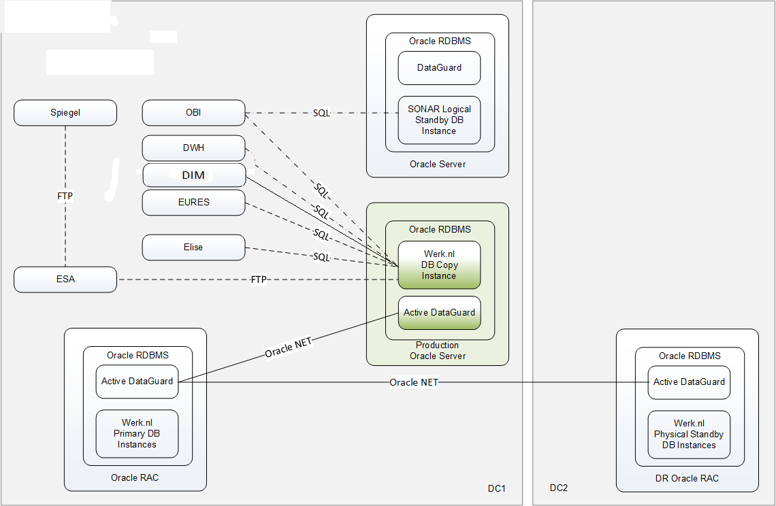

## System Context

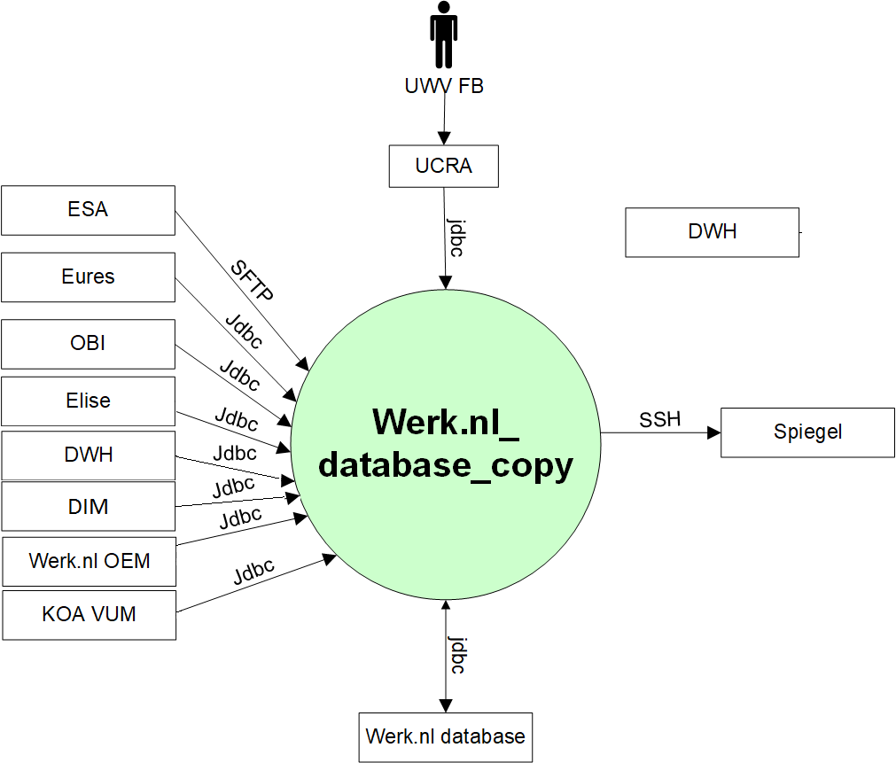

### External entities

#### UWV FB

|  |  |
| --- | --- |
| **Description** | UWV FB, functional maintenance generates reports and manages the postcode data. |
| **Protocol and Port** | jdbc (1521) |
| **DC (Datacenter) connection** | Internal (UCRA -> Werk.nl_database_copy) |
| **Direction** | Inbound |
| **Direct connection** | No, via UCRA |
| **Security Controls** | Not specified |
| **Number of users** | 5 - 10 |
| **Number of transactions** | Not specified |
| **Frequency of transactions** | Not specified |
| **Volume of data** | Not specified |

#### Werk.nl database

|  |  |
| --- | --- |
| **Description** | Werk.nl Primary database (on the 3-node Oracle RAC cluster) |
| **Protocol and Port** | jdbc (1521) |
| **DC (Datacenter) connection** | Internal |
| **Direction** | Incomming and outgoing |
| **Direct connection** | yes |
| **Security Controls** | Not specified |
| **Number of users** | Not specified |
| **Number of transactions** | Not specified |
| **Frequency of transactions** | Continuous updates to the database copy with a maximum delay of 15 minutes |
| **Volume of data** | WEDO instance has 1.7 TB // there are documents in the database that consume a lot of space |

#### Spiegel

|  |  |
| --- | --- |
| **Description** | Werk.nl_datbase_copy connection to Spiegel |
| **Protocol and Port** | SSH (22) |
| **DC (Datacenter) connection** | Internal |
| **Direction** | Outgoing |
| **Direct connection** | yes |
| **Security Controls** | Not specified |
| **Number of users** | 1-2 |
| **Number of transactions** | Several files |
| **Frequency of transactions** | Weekly |
| **Volume of data** | Medium, several 100MB |

#### ESA

|  |  |
| --- | --- |
| **Description** | ESA to Werk.nl_database_copy |
| **Protocol and Port** | SFTP (22) |
| **DC (Datacenter) connection** | Internal |
| **Direction** | Incomming |
| **Direct connection** | yes |
| **Security Controls** | Not specified |
| **Number of users** | Not specified |
| **Number of transactions** | Not specified |
| **Frequency of transactions** | Not specified |
| **Volume of data** | Not specified |

#### Eures

|  |  |
| --- | --- |
| **Description** | Eures retrieves job vacancies and CVs from the copy database. |
| **Protocol and Port** | jdbc (1521) |
| **DC (Datacenter) connection** | Internal |
| **Direction** | Incomming |
| **Direct connection** | yes |
| **Security Controls** | Not specified |
| **Number of users** | Not specified |
| **Number of transactions** | Not specified |
| **Frequency of transactions** | A scheduled extract once a day |
| **Volume of data** | Not specified |

#### OBI

|  |  |
| --- | --- |
| **Description** | Oracle Business Intelligence (OBI)  OBI implements the interface with a database link that is initiated from the OBI side and directly links into the WEDOK database. |
| **Protocol and Port** | jdbc (1521) |
| **DC (Datacenter) connection** | Internal |
| **Direction** | Incomming |
| **Direct connection** | yes |
| **Security Controls** | Not specified |
| **Number of users** | Not specified |
| **Number of transactions** | Not specified |
| **Frequency of transactions** | A scheduled extract once a day |
| **Volume of data** | Not specified |

#### Elise

|  |  |
| --- | --- |
| **Description** | EDR failover connection for Elise to retrieve job vacancies, CVs, profession and education from the copy database |
| **Protocol and Port** | jdbc (1521) |
| **DC (Datacenter) connection** | Internal |
| **Direction** | Incomming |
| **Direct connection** | yes |
| **Security Controls** | Not specified |
| **Number of users** | Not specified |
| **Number of transactions** | Not specified |
| **Frequency of transactions** | Not specified |
| **Volume of data** | Not specified |

#### DWH

|  |  |
| --- | --- |
| **Description** | DataWarehouse wants to extract data from WEDOK on a weekly basis.  UWV Security (CISO Officer) and UWV Legal (Data Privacy Officer) have given permission to DWH to extract data from the following database schema: BSA_OWNER, EIN_DIGID, REG_OWNER, SBI_OWNER, SCA_OWNER, SCV_OWNER, SGO_OWNER, SVG_OWNER, SWP_OWNER, SWR_OWNER, SZT_OWNER, VWS_OWNER, SKB  For large tables these extracts will be incremental based on the date of last modification (if available). Small tables will be extracted as a whole (full).  DWH implements the interface with a database link that is initiated from the DWH side and directly links into the WEDOK database.  Note:the current Werk.nl-DWH interface is implemented with file transfers over SIP (System Integration Platform). The interface runs on Mondays at 05.00 hours. |
| **Protocol and Port** | jdbc (1521) |
| **DC (Datacenter) connection** | Internal |
| **Direction** | Incomming |
| **Direct connection** | yes |
| **Security Controls** | the use of unencrypted communication is tolerated |
| **Number of users** | Not specified |
| **Number of transactions** | Not specified |
| **Frequency of transactions** | Once a week |
| **Volume of data** | Not specified |

#### DIM

|  |  |
| --- | --- |
| **Description** | Data Integratie magazijn (DIM) wants to extract data from WEDOK on a weekly basis.  UWV Security (CISO Officer) and UWV Legal (Data Privacy Officer) have given permission to DIM to extract data from the following database schema: BSA_OWNER, EIN_DIGID, REG_OWNER, SBI_OWNER, SCA_OWNER, SCV_OWNER, SGO_OWNER, SVG_OWNER, SWP_OWNER, SWR_OWNER, SZT_OWNER, VWS_OWNER, SKB  For large tables these extracts will be incremental based on the date of last modification (if available). Small tables will be extracted as a whole (full).  DIM implements the interface with a database link that is initiated from the DIM side and directly links into the WEDOK database.  Note:the new Werk.nl-DIM interface must be implemented with file transfers over SIP (System Integration Platform). The interface runs on Mondays at 05.00 hours. |
| **Protocol and Port** | jdbc (1521) ???? |
| **DC (Datacenter) connection** | Internal |
| **Direction** | Incomming |
| **Direct connection** | yes |
| **Security Controls** | the use of unencrypted communication is tolerated |
| **Number of users** | Not specified |
| **Number of transactions** | Not specified |
| **Frequency of transactions** | Once a week |
| **Volume of data** | Not specified |

#### Werk.nl OEM

|  |  |
| --- | --- |
| **Description** | Cloud Control solution for functional monitoring |
| **Protocol and Port** | jdbc (1521) |
| **DC (Datacenter) connection** | Internal |
| **Direction** | Incomming |
| **Direct connection** | yes |
| **Security Controls** | Not specified |
| **Number of users** | Not specified |
| **Number of transactions** | Not specified |
| **Frequency of transactions** | Not specified |
| **Volume of data** | Not specified |

#### KOA VUM

|  |  |
| --- | --- |
| **Description** | A KOA application combining data of job vacancies, resumes and profiles to exchange that with external parties. |
| **Protocol and Port** | jdbc (1521) |
| **DC (Datacenter) connection** | Internal |
| **Direction** | Incomming |
| **Direct connection** | Yes |
| **Security Controls** | Authorization method: Database account in the Werk.nl_database_copy |
| **Number of users** | 1 |
| **Number of transactions** | Daily scheduled retrieval of profiles |
| **Frequency of transactions** | Daily |
| **Volume of data** | Not specified |

# Functional Requirements

**Werk.nl data must be made available for querying**

|  |  |  |  |
| --- | --- | --- | --- |
| **ID** | 01 | **Necessity** | Essential |
| **Status (Input)** | Approved | **Status (Output)** | Satisfied |
| **Reach** | Local |  |  |
| **Requirement** | The copy database must be made available for querying. | | |
| **Description** | The copy database that is synchronized from the primary database must be opened for querying. | | |
| **Supporting SBBs** | Werk.nl_database_copy | | |

**Application queries must be scheduled**

|  |  |  |  |
| --- | --- | --- | --- |
| **ID** | 02 | **Necessity** | Optional |
| **Status (Input)** | Approved | **Status (Output)** | Satisfied |
| **Reach** | Local |  |  |
| **Requirement** | UWV must manage all applications that run queries against the copy database to prevent multiple queries | | |
| **Description** | UWV must manage when what application runs which query to ensure that the environment has a predictable workload. Ad-hoc queries must be prevented. | | |
| **Supporting SBBs** | Werk.nl_database_copy | | |

**Applications have their own database account that gives read-only access**

|  |  |  |  |
| --- | --- | --- | --- |
| **ID** | 03 | **Necessity** | Essential |
| **Status (Input)** | Approved | **Status (Output)** | Satisfied |
| **Reach** | Local |  |  |
| **Requirement** | Each application that wants to read data must have its own database account. | | |
| **Description** | Each application must be identifiable to support tracking & tracing of workload. | | |
| **Supporting SBBs** | Werk.nl_database_copy | | |

**All schemas of Werk.nl WEDO database must be accessible in read-only mode**

|  |  |  |  |
| --- | --- | --- | --- |
| **ID** | 04 | **Necessity** | Essential |
| **Status (Input)** | Approved | **Status (Output)** | Satisfied |
| **Reach** | Local |  |  |
| **Requirement** | All schemas in the copy database must be accessible in read-only mode.  Note that access to all schemas depends on the security permission given to a specific WEDOK client. | | |
| **Description** | Clients must be able to read data from all schemas in the copy database. | | |
| **Supporting SBBs** | Werk.nl_database_copy | | |

**Changes to the primary Werk.nl database (like Create, Update, Delete tables) must automatically become available in the copy database**

|  |  |  |  |
| --- | --- | --- | --- |
| **ID** | 05 | **Necessity** | Essential |
| **Status (Input)** | Approved | **Status (Output)** | Satisfied |
| **Reach** | Local |  |  |
| **Requirement** | The copy database must follow the primary database regarding changes in Data Definition Language (DDL) that are applied to the primary database. | | |
| **Description** | The changes (tables, views, and other database objects) that are applied on the primary database must also be applied to the copy database. | | |
| **Supporting SBBs** | Werk.nl_database_copy | | |

**Applications may access the WEDOK copy database via an Oracle DB-link**

|  |  |  |  |
| --- | --- | --- | --- |
| **ID** | 06 | **Necessity** | Essential |
| **Status (Input)** | Approved | **Status (Output)** | Optional |
| **Reach** | Local |  |  |
| **Requirement** | Applications may use an Oracle database link as connection method between the application database and the copy database. | | |
| **Description** | Applications may use an Oracle database link to connect their database to the copy database. | | |
| **Supporting SBBs** | Werk.nl_database_copy | | |

**Applications may extract incremental data**

|  |  |  |  |
| --- | --- | --- | --- |
| **ID** | 07 | **Necessity** | Essential |
| **Status (Input)** | Approved | **Status (Output)** | Optional |
| **Reach** | Local |  |  |
| **Requirement** | Applications may extract incremental data based on the date of last modification. The increments are daily. | | |
| **Description** | Applications may extract incremental data. The date of last modification (field in a table) will be used for this purpose. This may require changes to the source tables, as the copy database is a one-to-one copy of the source data. | | |
| **Supporting SBBs** | Werk.nl_database_copy | | |

**Maximum delay for data in copy database**

|  |  |  |  |
| --- | --- | --- | --- |
| **ID** | 08 | **Necessity** | Essential |
| **Status (Input)** | Approved | **Status (Output)** | Satisfied |
| **Reach** | Local |  |  |
| **Requirement** | The maximum delay for data to become available in the copy database is set at 15 minutes. | | |
| **Description** | Applications require a pseudo online view on the WEDO operational data. Therefore, the copy copy must not be lagging more than this interval. | | |
| **Supporting SBBs** | Werk.nl_database_copy | | |

**Applications may extract Full data**

|  |  |  |  |
| --- | --- | --- | --- |
| **ID** | 09 | **Necessity** | Essential |
| **Status (Input)** | Approved | **Status (Output)** | Satisfied |
|  |  |  |  |
| **Reach** | Local |  |  |
| **Requirement** | Applications may extract all rows (full data).  Note that this may have impact on performance or response times as there are huge tables involved. | | |
| **Description** | An application may extract huge tables. | | |
| **Supporting SBBs** | Werk.nl_database_copy | | |

# Non-Functional Requirements

## Security & Compliance classifications

Repository used is: “2022 UWV-brede Risico Applicatie Lijst v1.0”

The BIV rating (confidentiality) will result in chosing the UWV data appropriate zoning principals.

recovery requirements applicable.

|  |  |
| --- | --- |
| **Application** | WEDOK (Werk.nl_database_copy) |
| **Owner** | WB |
| **Availability (Beschikbaarheid)** | Not specified |
| **Integrity (Integriteit)** | Not specified |
| **Confidentiality (Vertrouwelijkheid)** | 2+ |
| **Type of information /Data Classification** | Not specified |
| **Direct or Indirect part of the primary information chain** | Not specified |

The following assumption is made and agreed with UWV PM: Data is a copy for the Werk.nl DB, so the same confidentiality classification (2+) is used as for the original data.

### Risk Analysis UWV

No risk analysis provided by UWV.

### Applicable security and compliance frameworks

|  |  |
| --- | --- |
| Security & Compliance Framework | Applicable |
| BIR 2017 | Yes |
| AVG / GDPR | Yes |
| DIGID | No |
| SUWI | No |
| Additional frameworks | Not specified |

## Capacity and Performance (Volumetrics)

**Storage size must be identical with WEDO size**

|  |  |  |  |
| --- | --- | --- | --- |
| **ID** | 01 | **Necessity** | Essential |
| **Status (Input)** | Approved | **Status (Output)** | Satisfied |
| **Reach** | Local |  |  |
| **Requirement** | As WEDOK must have a storage size that is identical to the Werk.nl WEDO database because it is a physical copy database. | | |
| **Description** | All information from the WEDO database will be synchronized to the physical copy database. | | |
| **Supporting SBBs** | SBB-WEDOK-01 | | |

## Availability

|  |  |  |  |  |
| --- | --- | --- | --- | --- |
| **Environment** | **Application Target** | **Application Service Hours** | **Infra Target** | **Infra Service Hours** |
| Production | 98% | 5 x 12 (Mo-Fr, 7-19h) | 99.5% | 7 x 24 |
| Acceptance | 98% | 5 x 12 (Mo-Fr, 7-19h) | 98% | 5 x 12 (Mo-Fr, 7-19h) |

## Security requirements

User accounts must be created on the primary server and will be propagated to the copy database. Some users will have access to the primary database and will also automatically get access to the copy database.

Some WEDOK applications are only allowed to have read access to the copy database. WEDOK applications must have a user account on the copy database. Some users that have access to the copy database must not be able to logon on the primary database.

User and application access to WEDOK must be approved by UWV Security.

Database access is only allowed for DXC Database Administrators (DXC DBA). UWV FB may use Oracle SQLDeveloper or other tools to access the WEDOK copy database.

Detailed security requirements are documented in Appendix D

## System management

No specific system management requirements are applicable

## Backup and Recovery

No database backup is required, restore must be done by recreating the copy database from the Werk.nl primary database using Oracle Data Guard.

## Storage replication

|  |  |
| --- | --- |
| **Environment** | **Storage type** |
| Production | Replicated |
| Acceptance | Not replicated |

## Scalability

To support the application growth the system must be vertical scalable

## Disaster Recovery

No specific disaster recovery requirements are applicable.

## Technical Constraints

No technical contrains.

## DXC TAB requirements

|  |  |
| --- | --- |
| **Category** | **Description** |
| Deployment | * jdbc (1521) connection from Werk.nl TAB deployment to the Werk.nl_database_copy is required |
| Other TAB applicable requirement | * jdbc (1521) connection from Werk.nl OEM to the Werk.nl_database_copy is required |

# Appendix A: Template version control

**TEMPLATE CHANGE HISTORY**

|  |  |  |
| --- | --- | --- |
| Version | Date | Summary of Changes |
| 0.1 | 08-07-2022 | * Initial version UWV requirements template, ready for review |
| 0.2 | 13-07-2022 | * Included review comments Giuliana to prepare for follow-up meeting |
| 0.3 | 14-07-2022 | * Included review comments Giuliana and Henk-Jan to prepare for REQ template pilot |
| 0.8 | 14-07-2022 | * Cora marked the REQ template v0.8.  Prepared for final UWV review and the additional writer’s instruction from Thomas H, Remco H and Walter |
| 0.9 | 25-07-2022 | * Pre-pilot version |
| 0.91 | 27-07-2022 | * Split Appendix A in A and B for document control |
| 0.92 | 11-08-2022 | * improved instructions after 1st workshop with IO&R hosting team and evaluation of pilot (use case: edit HLD for existing application) |
| 0.93 | 24-08-2022 | * improved instructions after 2nd workshop with IO&R hosting team |
| 0.99 | 28-10-2022 | * Improved and added instructions by Henk-Jan after evaluation of first use in production and to finalize template to v1.0 |
| 1.0 | 11-01-2022 | Finalized with the following adjustments   * Updated 4.4 includes service level and service hours * Updated 4.8 Added note for AIX Bronze systems |
| 1.1 | 02-01-2023 | * Updated instructions for certificate selection |
| 1.2 | 23-02-2023 | Updated the template with MCPaaS (Managed Container Platform as a Service) specific requirements   * Removed Chapter 3 (functional requirements), Evaluation shows that this is either not filled or when it is filled the requirements are non-funtional. Functional requirements for the application are documented in the application design (SAD) * Moved chapter 4.8 (storage replication) under 3.2.1 to bundle the Private Cloud (build)requirements together * Moved chapter 4.4 (Availibility), 4.6 (System management) and 4.10 (TAB requirements) under 3.2.1 and 3.2.2 to bundle the Private Cloud system and Container application requirements together * Moved chapter under 3.2.1 and 3.2.2 to bundle the Private Cloud system and Container application requirements together * Updated 4.2 System and Software requirements: seperate section for Private Cloud and MCPaaS * Updated 4.4 Availability: seperate section for Private Cloud and MCPaaS * 4.6.1 – added addition MCPaaS related infra requirement: Can the standard azure container registry be used by the MCPaaS application |
| 1.21 |  | Added Chapter 3 again: Functional requirements, to keep all chapter the same also for old documentation and to have the possibility to document functional requirements that might seem relevant  Updated 4.2.1.5 System management   * Added load balancer requirements * Added known application scalability limitations |

# Appendix B: Document version control

**USED TEMPLATE**

|  |
| --- |
| Based on REQ Template: UWV REQ – TEMPLATE 1.2.docx |

**CHANGE HISTORY**

|  |  |  |  |
| --- | --- | --- | --- |
| Version | Date | Author | Summary of Changes |
|  |  |  |  |
|  |  |  |  |
|  |  |  |  |
|  |  |  |  |
|  |  |  |  |
|  |  |  |  |

# Appendix C: Legenda

## Legenda Context Diagram

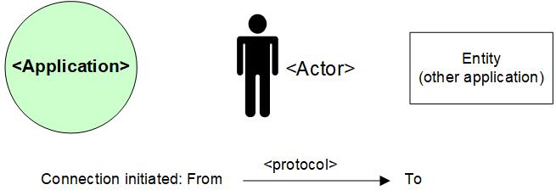

# Appendix D: MCPaaS – Capacity allocation details

**EXAMPLE**

**Capacity allocation for <CompetentNL>**

To manage the resource allocation and assure the project uses only appropriate or agreed resources on the cluster, the quotas and limits to compute resources for the CompetentNL projects on the MCPaaS will be based on below details.

|  |  |  |  |  |  |  |
| --- | --- | --- | --- | --- | --- | --- |
| **Service (pod)** | **Mem Reservation** | **Mem Limit** | **CPU Reservation** | **CPU Limit** | **Scale - nr of containers (Development)** | **Scale - nr of containers (Test)** |
| CNL-Backend | 256M | 512M | 0,1 | 0,3 | 1 | 1 |
| CNL-Frontend | 128M | 256M | 0,1 | 0,5 | 1 | 1 |
| CNL-IAM | 256M | 512M | 0,1 | 0.5 | 1 | 1 |
| CNL-Dataloader | 256M | 512M | 0,1 | 0,2 | 1 | 1 |
| CNL ActiveMQ | 256M | 512M | 0,1 | 0,3 | 1 | 1 |
| CNL-Config-server | 128M | 256M | 0,1 | 0,2 | 1 | 1 |
| CNL-api | 256M | 512M | 0,1 | 0,5 | 1 | 1 |
| CNL-Synchronization | 128M | 256M | 0,1 | 0,3 | 1 | 1 |
| CNL-DB Management | 128M | 256M | 0,1 | 0,2 | 1 | 1 |
| CNL-Search | 1024M | 3072M | 0,1 | 1 | 1 | 1 |

*Total Required resource allocation*

*Note: Required resource allocation for Development and Test is an initial estimation. After initial tests on these environments resource allocation for all environments will be finalized and updated. Besides the resource allocation for Acceptance and Production are based on the experiences from Development and Test.*

|  |  |  |  |  |
| --- | --- | --- | --- | --- |
| **Size description** | **Development** | **Test** | **Acceptance** | **Production** |
| Mem minimum run | 2816M | 2816M | TBD | |
| Mem maximum run | 6656M | 6656M |
| CPU reservations | 1 | 1 |
| CPU reservations limit | 4 | 4 |